Important safety information is presented throughout this document using the following signal words:

|  |  |
| --- | --- |
| DANGER: | Severe injury or death will occur if you ignore the message. |
| WARNING: | Severe injury or death can occur if you ignore the message. |
| CAUTION: | Minor injury or damage to your case can occur if you ignore the message. |
| NOTICE: | This is important installation, operation, or service information. If you ignore the message, you may damage your case. |

|  |
| --- |
| This is the safety-alert symbol. When you see this symbol on your case or in the manual, be alert to the potential for personal injury or damage to your equipment. |
| NOTICE  Read this manual before installing your case. Keep this manual and refer to it before doing any service on the equipment. Failure to do so could result in personal injury or damage to the case. |
| NOTICE  Installation and service of the electrical components in the case must be performed by a licensed electrician. The portions of this manual covering components contain technical instructions intended only for persons qualified to perform electrical work. |
| DANGER  Improper or faulty hookup of electrical components in the case can result in severe injury or death. All electrical wiring hookups must be done in accordance with all applicable local, regional, or national standards. |
| DANGER  This is the Danger-Flammable symbol. When you see this symbol on your case or in the manual, be alert to the potential for risk of fire or explosion. Be sure you understand all the safety messages and always follow recommended precautions and safe operating procedures. |

Locating The Display Case

Avoid locating this unit next to sources of air flow and heat:

Heating ducts, grills/fryers, radiators, ceiling fans, exterior doors/entrances/exits, and other sources of moving air and/or extreme hot/cold temperatures.

Avoid locating this unit in humid locations:

Misters/foggers and humidification devices or their discharge areas.

If this case or cases are to be located against a wall there should be at least 6” between the case and the wall to allow air circulation. Failure to give adequate space may cause exterior surfaces to sweat.

Removing Case From Shipping Skid

Be sure to leave shelf packaging material intact for this step. First remove the base front and rear panels Two or more people should be involved in moving the unit from the pallet onto the ground. Remove the (4) 1/4” screws that secure the case to the skid. These screws are located in the front and rear corners of the base rails. Base front and rear panels must be removed to access these bolts.



Once all the bolts are removed, slide the unit off the back of the shipping pallet, and tilt it so the rear corner touches the ground. Then have someone move pallet out from under the case and gently tilt the case forward until it touches the floor.

Lifting and Moving the Case

|  |
| --- |
| CAUTION  Removing the case requires a minimum of two people. Do not attempt to remove this unit from the shipping pallet by yourself. |
| CAUTION  Do not push or pull against the glass air deflector on front of case. Doing so can cause the glass to break. Do not push or pull on side glass or pull on base panel. Doing so will break glass or pull out panel mounting screws. |

Leveling the Case

It is important that the case is level. A wrench is included to aid in adjusting leg levelers. Check the left-to-right level of the case along front of plastic air deflector retainer. Check the front-to-rear level of the case along the interior ends of the case. Adjust the leg levelers as needed to level the casse in each direction.

Cleaning: Unit must be cleaned before initial use. See full manual for instructions.

**Electronic Temperature Control (Refrigerated units only)**

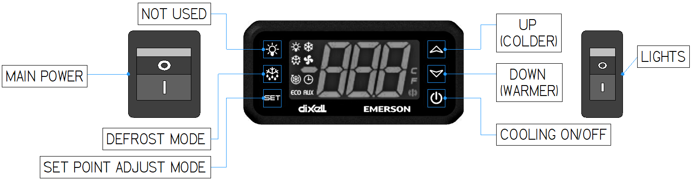

**Initial Startup (Refrigerated units only)**

|  |
| --- |
| NOTICE  This refrigerated display case is designed to operate in a maximum environment of 80°F and 55% relative humidity. Exceeding these limits will cause poor case performance and sweating. |

For more detailed information on control operation see the section “Electronic Temperature Control” in the full manual.

**Placing Product into Case**

|  |
| --- |
| NOTICE  **Load items at 38°F or colder**. At time of loading, items stocked in unit **MUST** be pre-chilled. Items must be 38°F or colder. |

Do not exceed 150 pounds of weight per shelf. Heavy product should be distributed evenly across the entire shelving area. Allow two inches of space behind and above stocked items.

Allow a minimum of 2” between top of product and bottom of next shelf up.

Allow refrigerated models to run for at least two hours before placing pre-chilled product into unit.

|  |
| --- |
| NOTICE  Risk of Electric Shock. If the cord or plug becomes damaged, replace only with a cord and plug of the same type. |

**Cord Connected (STANDARD)**

* A factory installed power cord is properly sized to the amperage requirements of the case. See the electrical data plate located on the rear exterior of the case for the proper circuit size for each case.
* The cord is factory installed protruding from the rear corner of the case.
* A separate circuit for each display case is required to prevent other appliances on the same circuit from overloading the circuit and causing malfunction.

See full installation and operation manual on Federal’s website by scanning the QR code:  
  
<https://federalind.com/docs/vrss-vnss-manual>

|  |
| --- |
| NOTICE  Shelves must be installed in the proper order from bottom to top or performance will be affected.  If shelving is installed out of order product will not hold temperature. |

